Task 5: Medical Cost Prediction Using Machine Learning

Objective
To develop a machine learning model that predicts a patient's medical insurance cost based on demographic and health-related attributes such as age, gender, BMI, number of children, smoking status, and region.

Description
Developed a medical cost prediction system using a healthcare insurance dataset. The project involved data preprocessing, exploratory data analysis (EDA), feature engineering, model training, evaluation, and prediction of medical insurance charges using machine learning algorithms.

Technologies Used
- Python
- Jupyter Notebook
- Pandas
- NumPy
- Matplotlib
- Scikit-learn

Activities Performed
- Loaded and explored the medical insurance dataset.
- Cleaned and preprocessed the data.
- Encoded categorical variables such as gender, smoker status, and region.
- Performed Exploratory Data Analysis (EDA).
- Split the dataset into training and testing sets.
- Trained machine learning models:
  - Decision Tree Regressor
  - Random Forest Regressor
  - AdaBoost Regressor
- Evaluated model performance using regression metrics.
- Predicted medical insurance costs for new patient data.

Evaluation Metrics
- Mean Absolute Error (MAE)
- Mean Squared Error (MSE)
- Root Mean Squared Error (RMSE)
- R² Score (Coefficient of Determination)

Outcome
Successfully developed a machine learning model capable of predicting medical insurance costs based on patient information. The project demonstrated how regression algorithms can be applied to estimate healthcare expenses accurately.

Skills Acquired
- Data Preprocessing
- Feature Engineering
- Exploratory Data Analysis (EDA)
- Regression Algorithms
- Decision Tree Regressor
- Random Forest Regressor
- AdaBoost Regressor
- Model Evaluation
- Predictive Analytics

Output
- Displayed the performance metrics of each regression model.
- Compared the prediction accuracy of Decision Tree, Random Forest, and AdaBoost models.
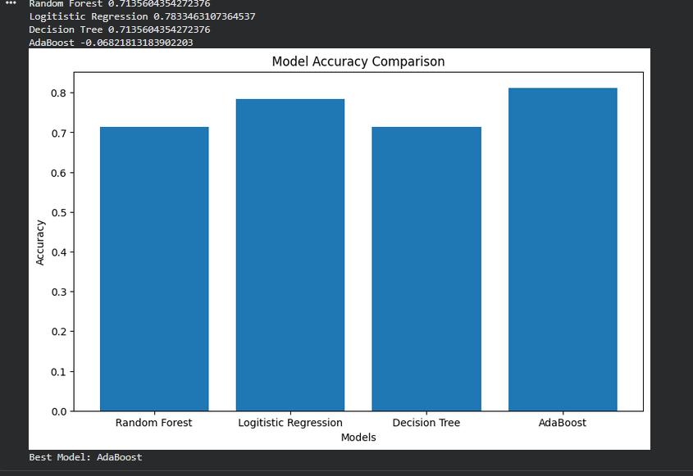
- Successfully predicted the estimated medical insurance cost for new patient information.
